MODULE 4: INTRODUCTIONN of dbms
EATRA LAB EXERCISES
9.DATA CONTROL LANGUAGE (DCL):
1.create two new users user1 and user2 and grant user1 permission to SELECT from the courses table. 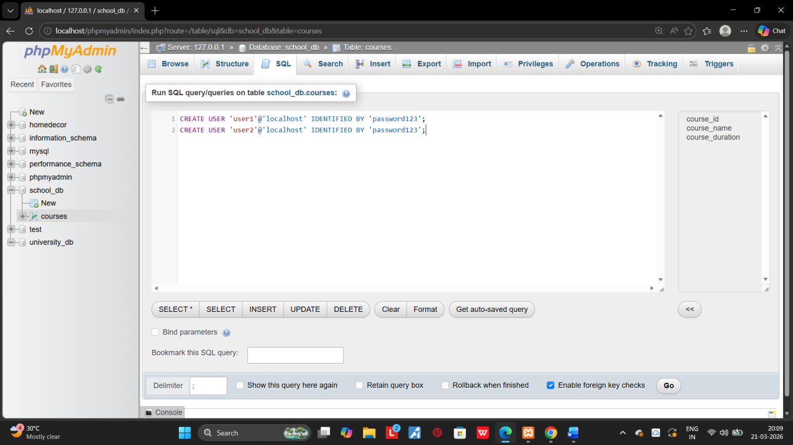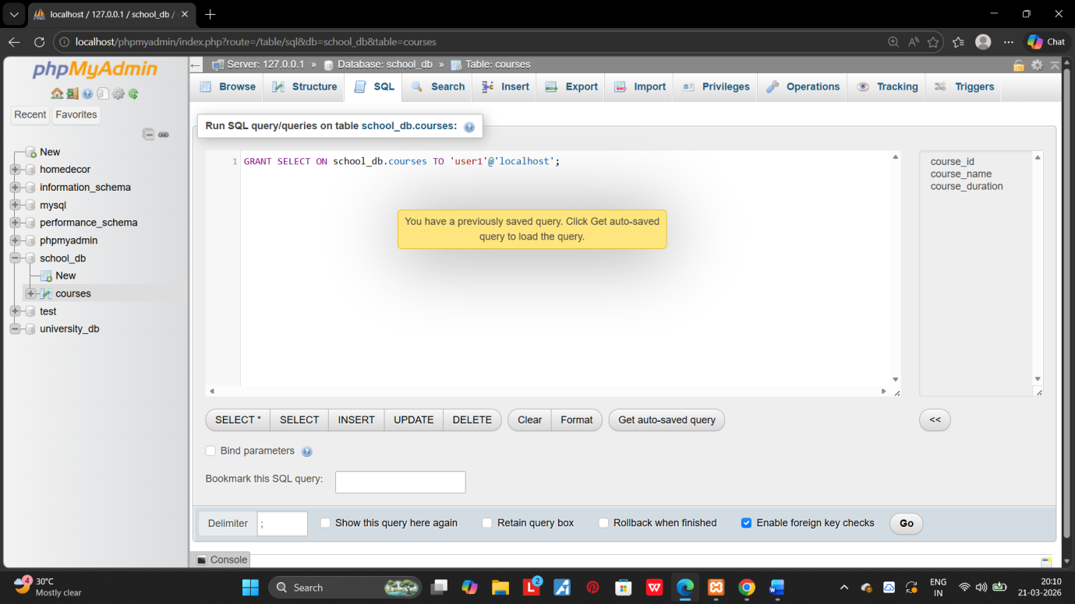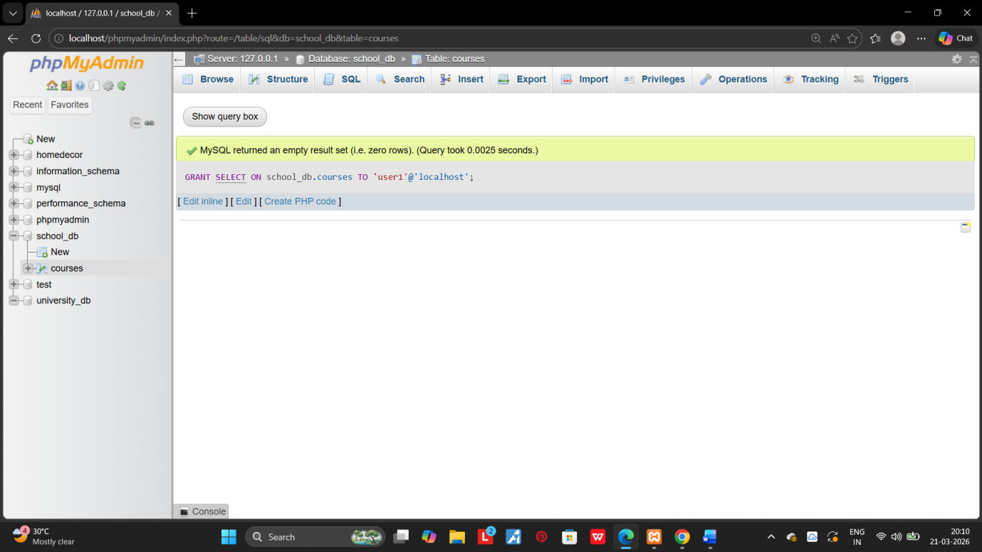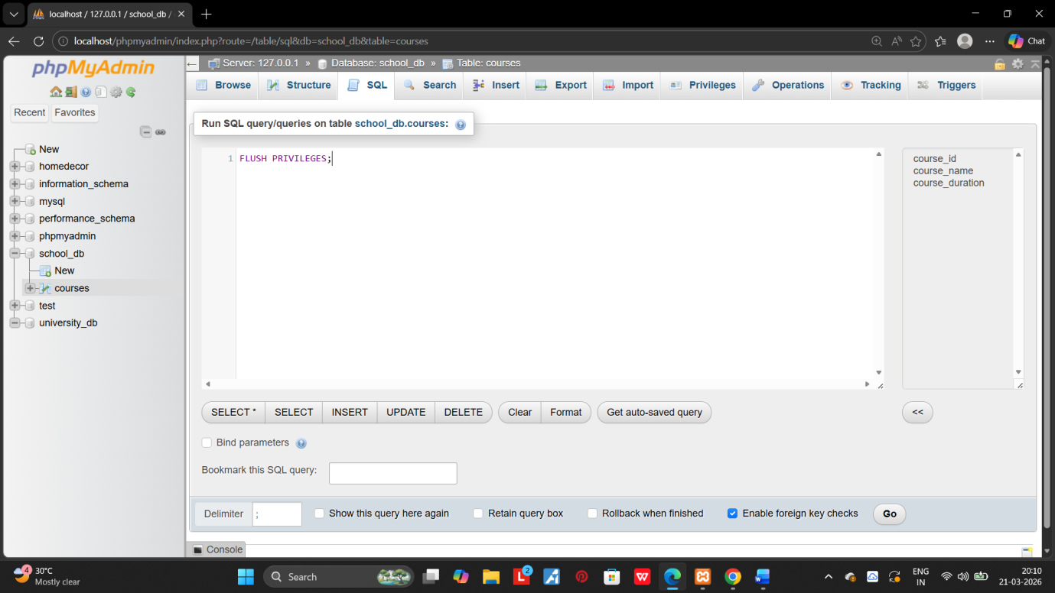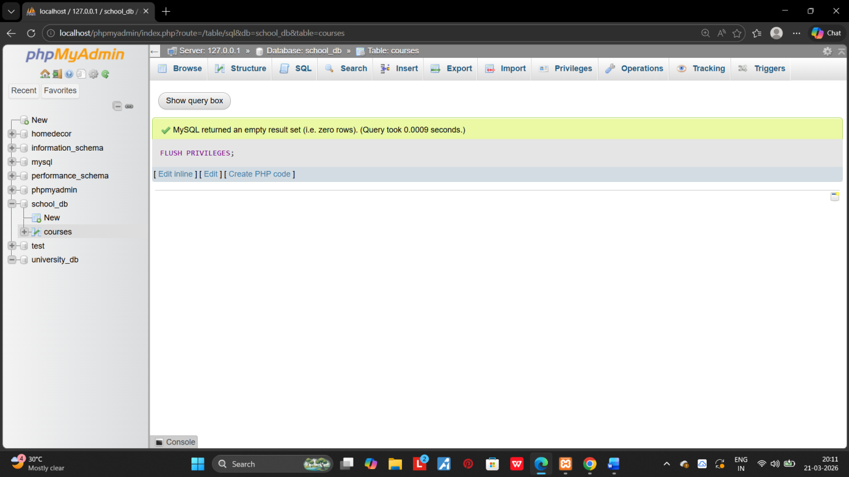

2.Revoke the Insert permission from user1 and give it to user2. 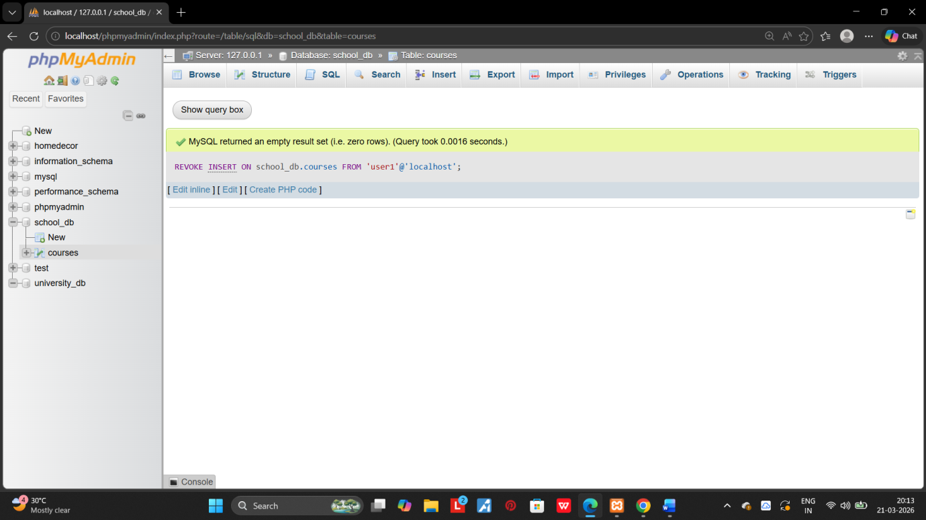
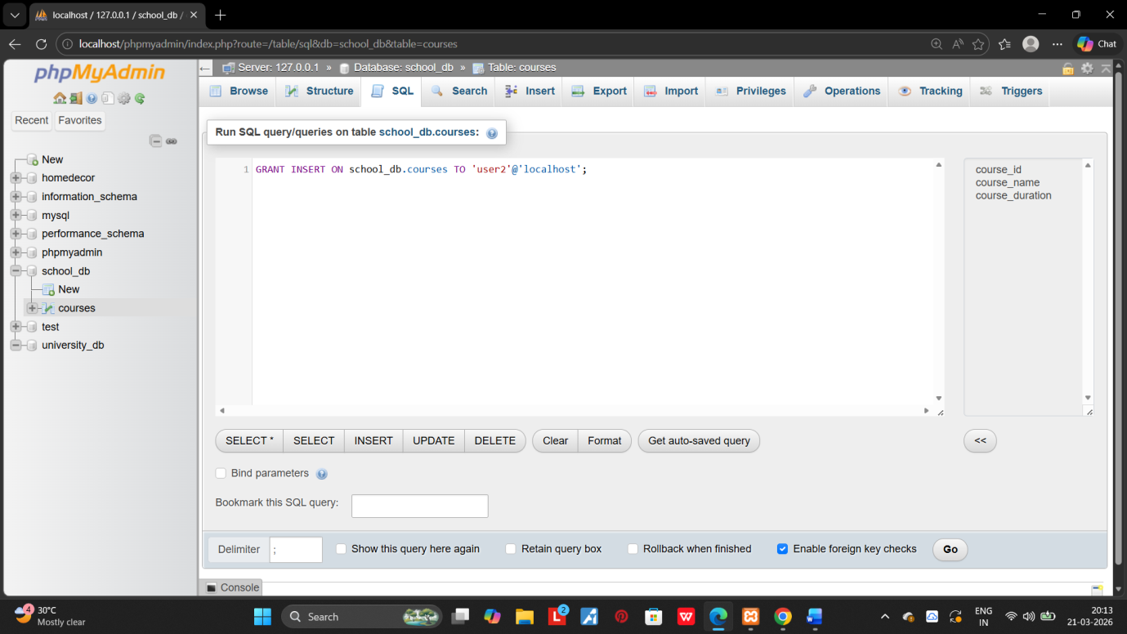

10.TRANSACTION CONTROL LANGUAGE (TCL):

1.Inset a few rows into the courses table and use COMMIT to save the changes. 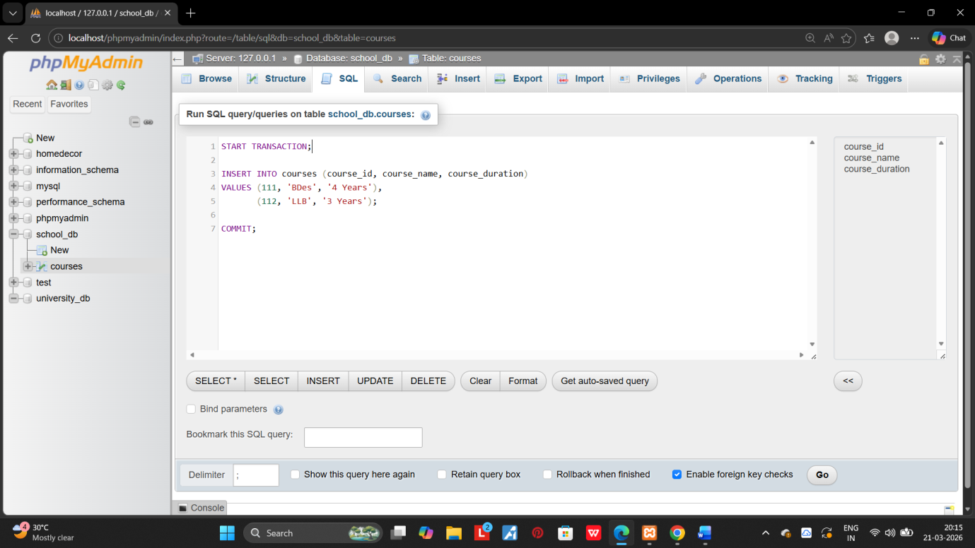 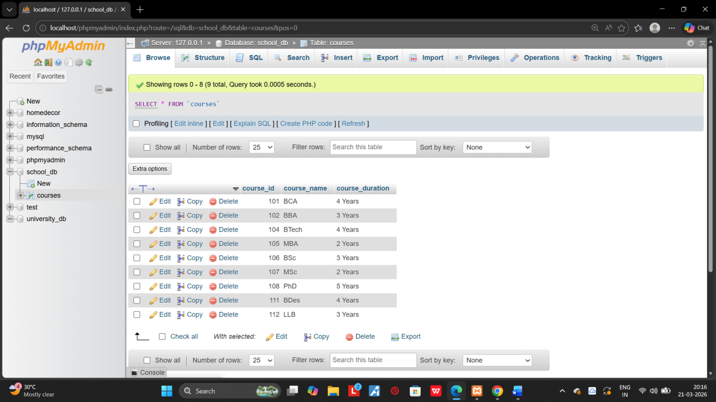
2.Insert additional rows , then use ROLLBACK ton undo the last insert operation. 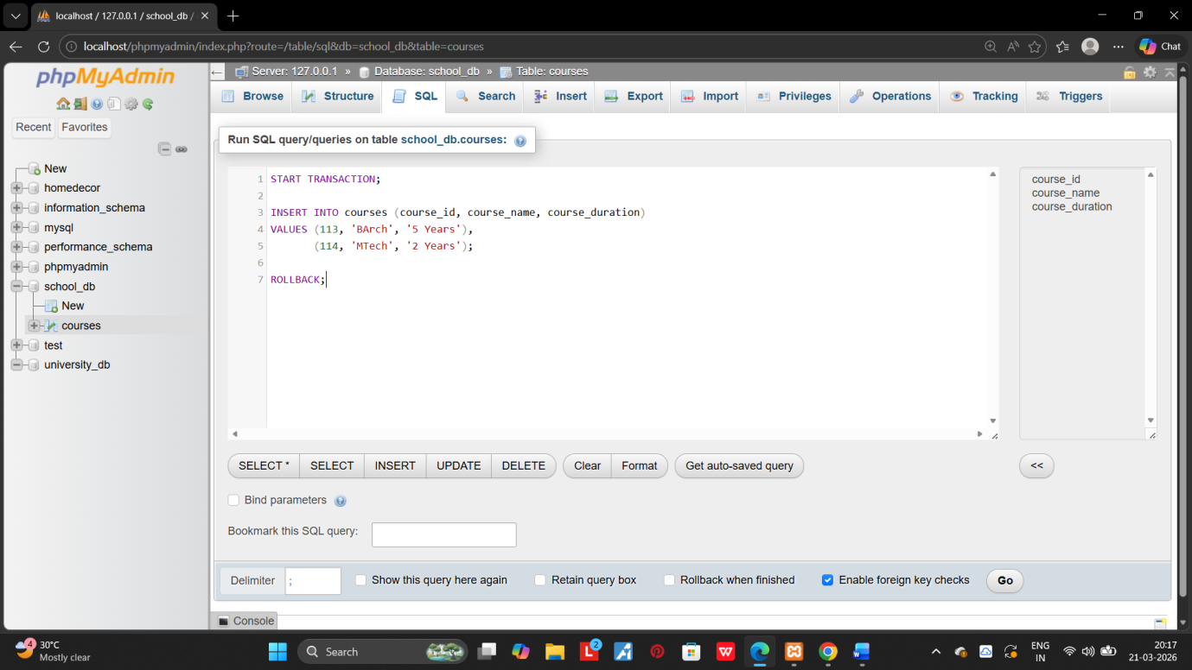

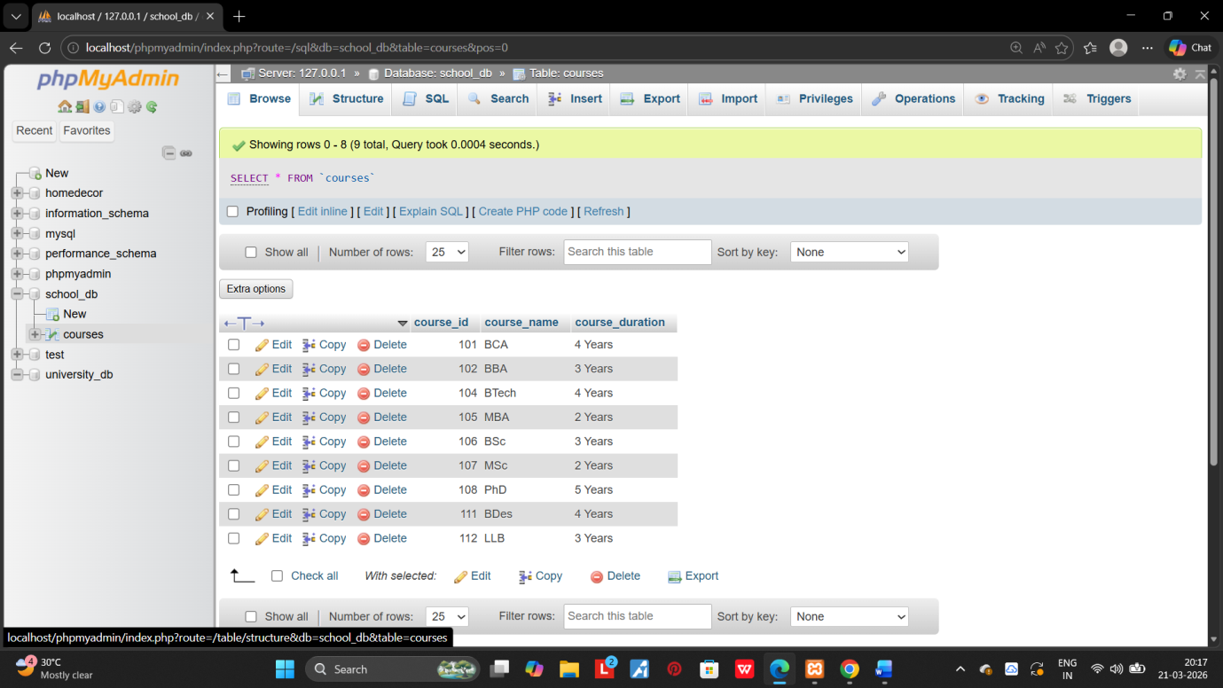

3.create a SAVEPOINT before updating the courses table , and use it to roll back specific changes.
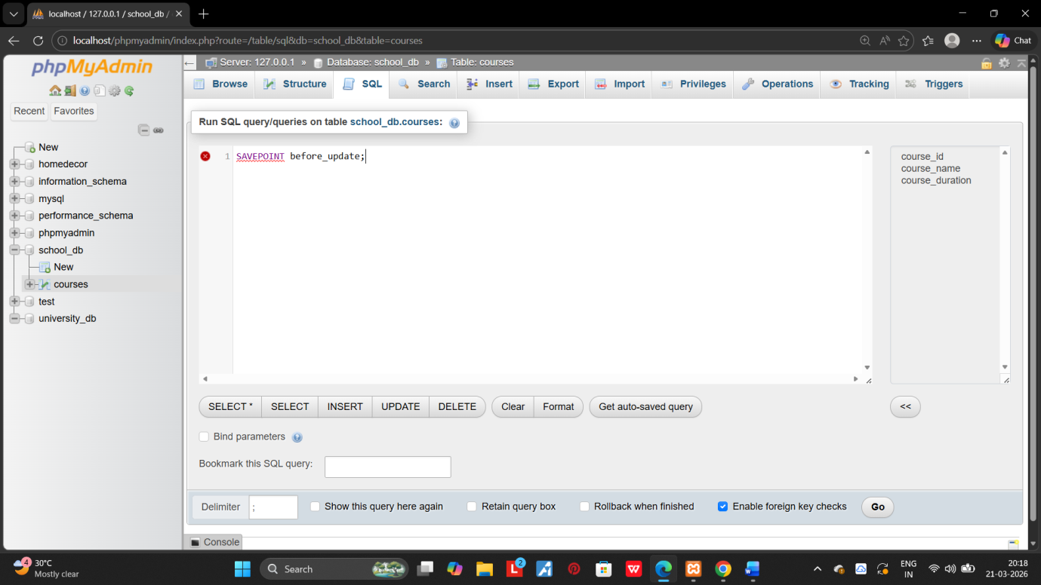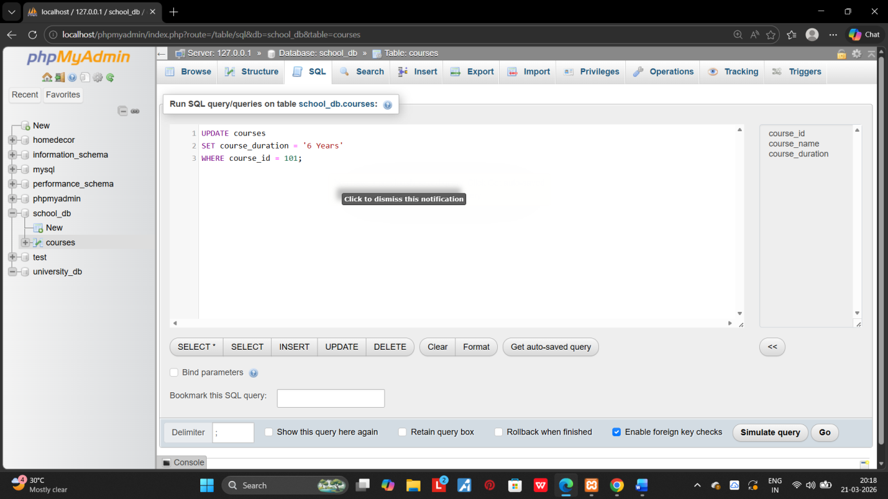.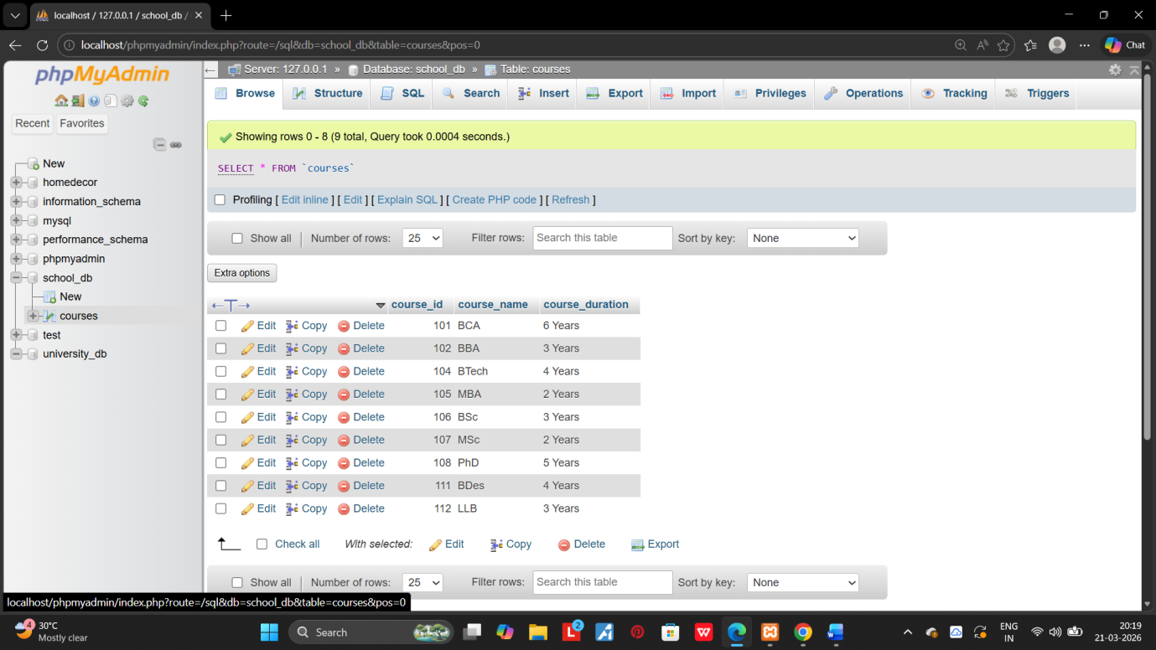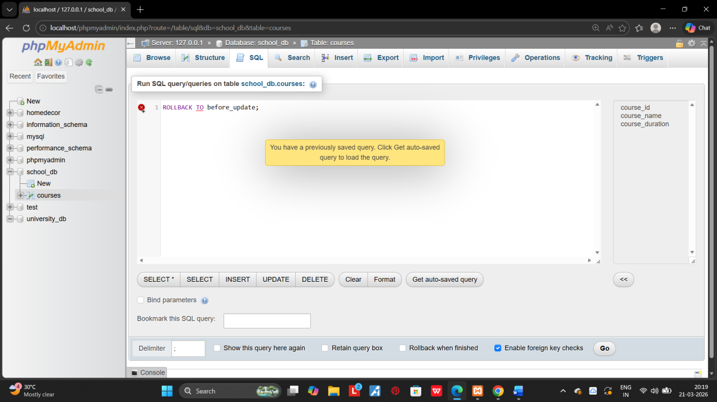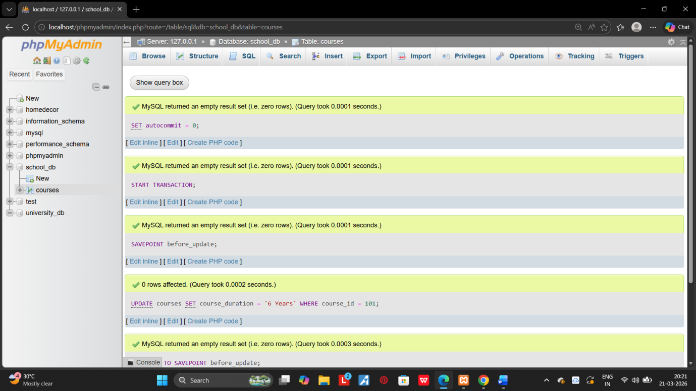
11.SQL JOINS :

1.Create teo table: departments and employees.perform INNER JOIN to display employees along with their respective deparments.
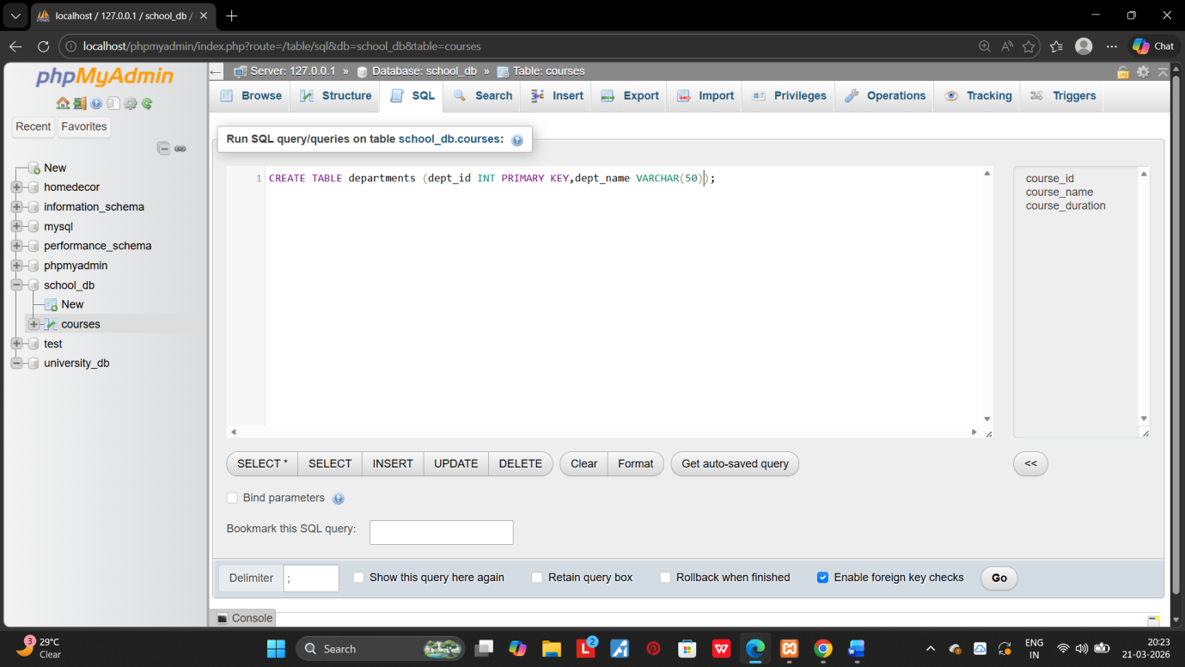
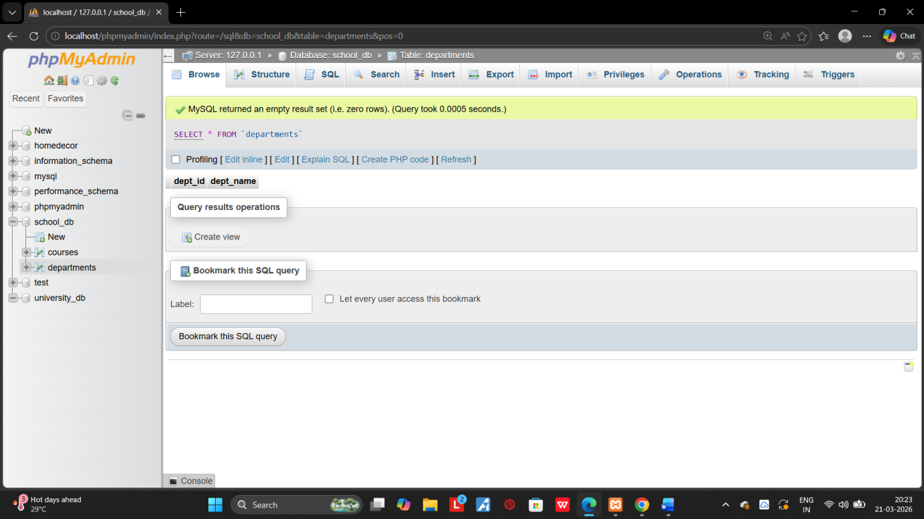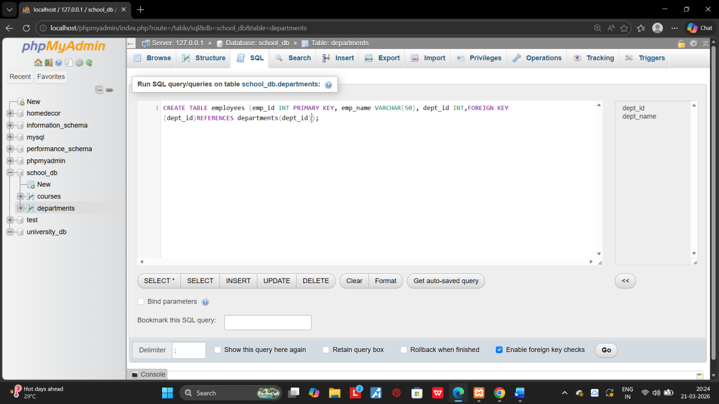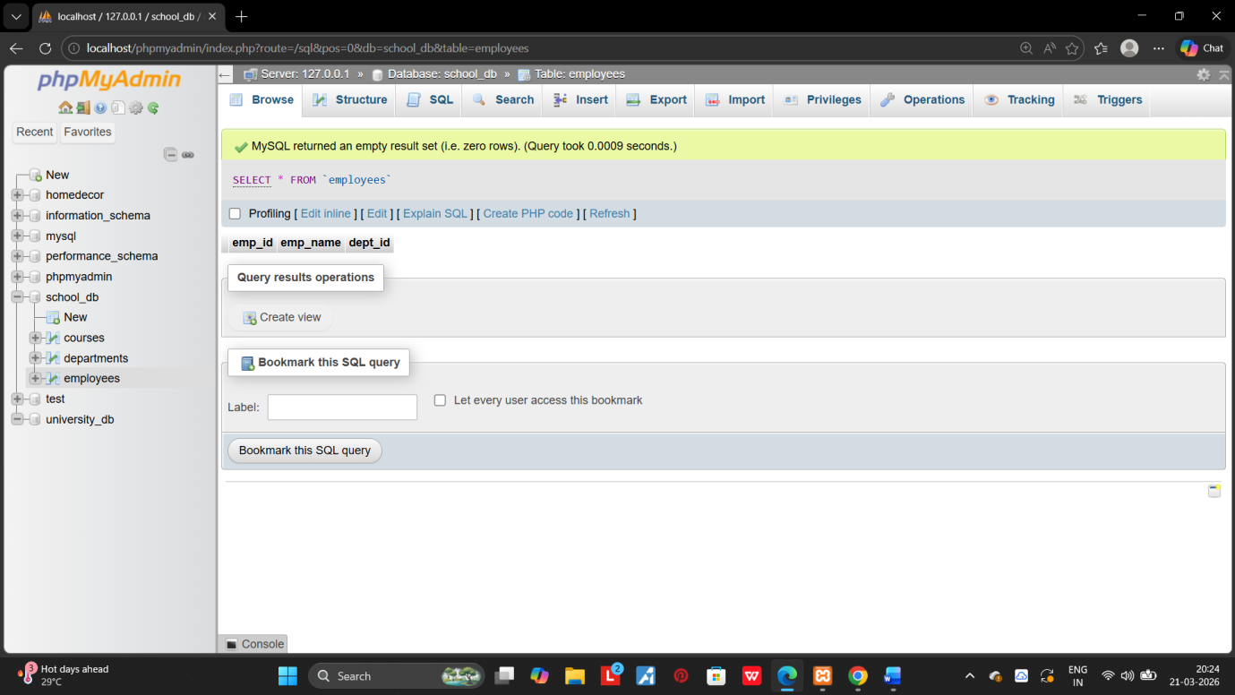
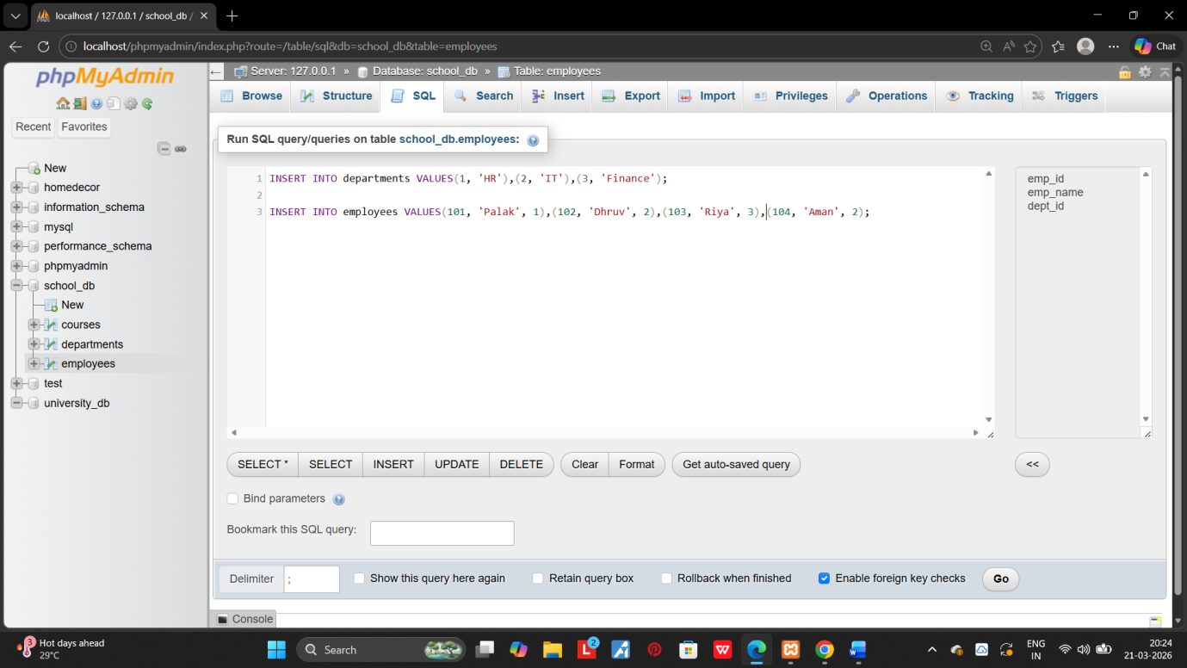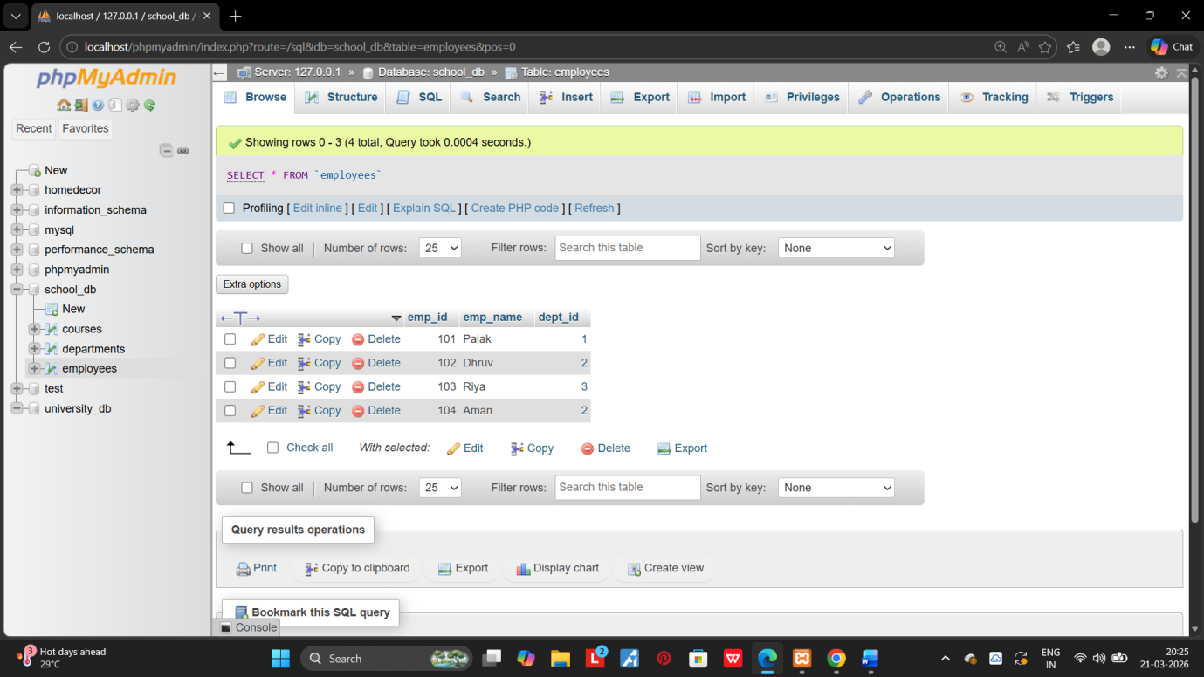
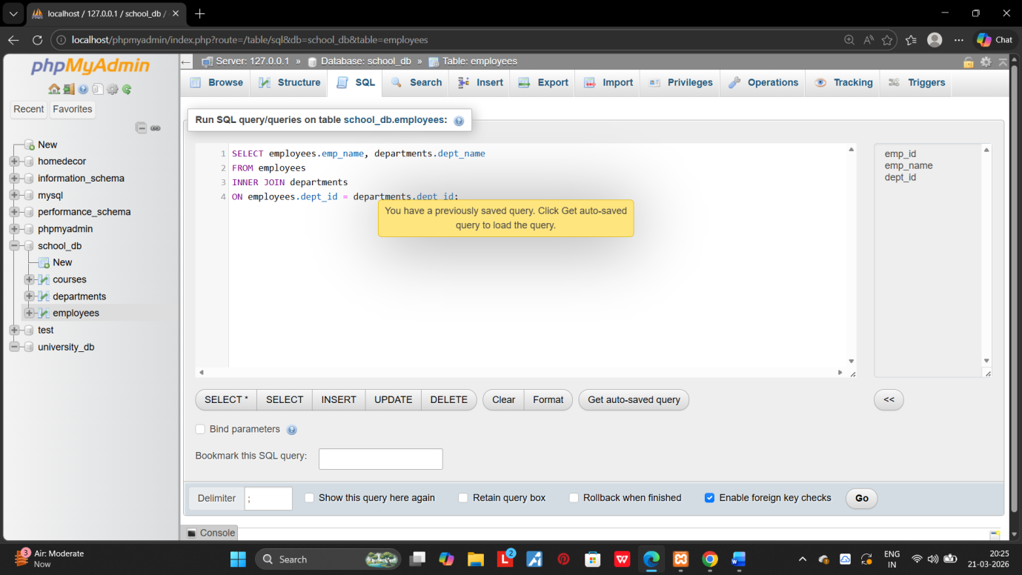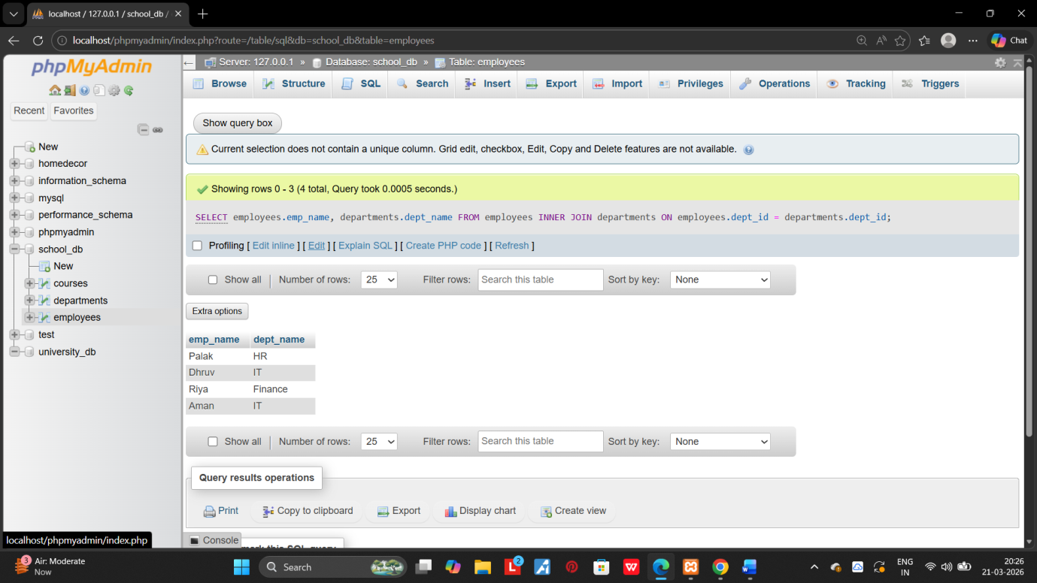
2.Use a LEFT JOIN to show all departments, even those without employees. 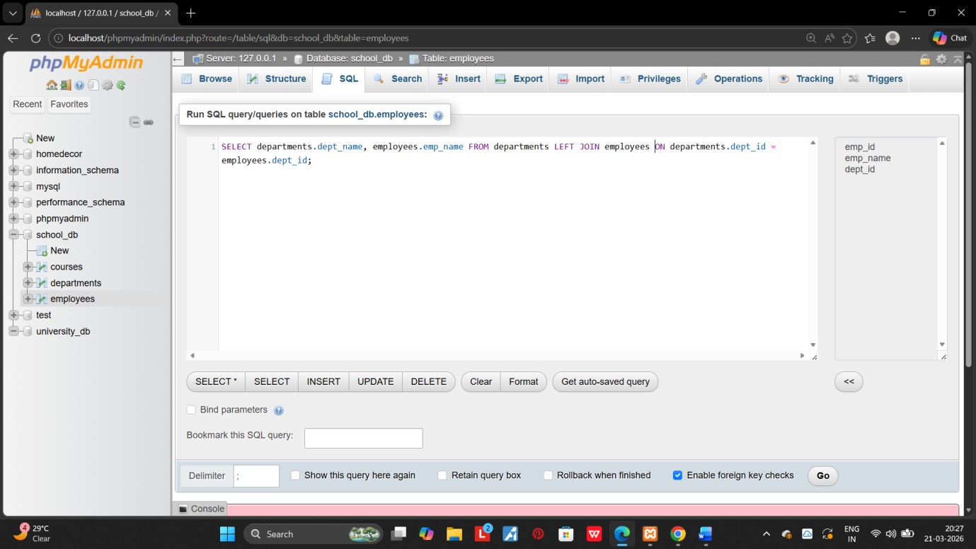
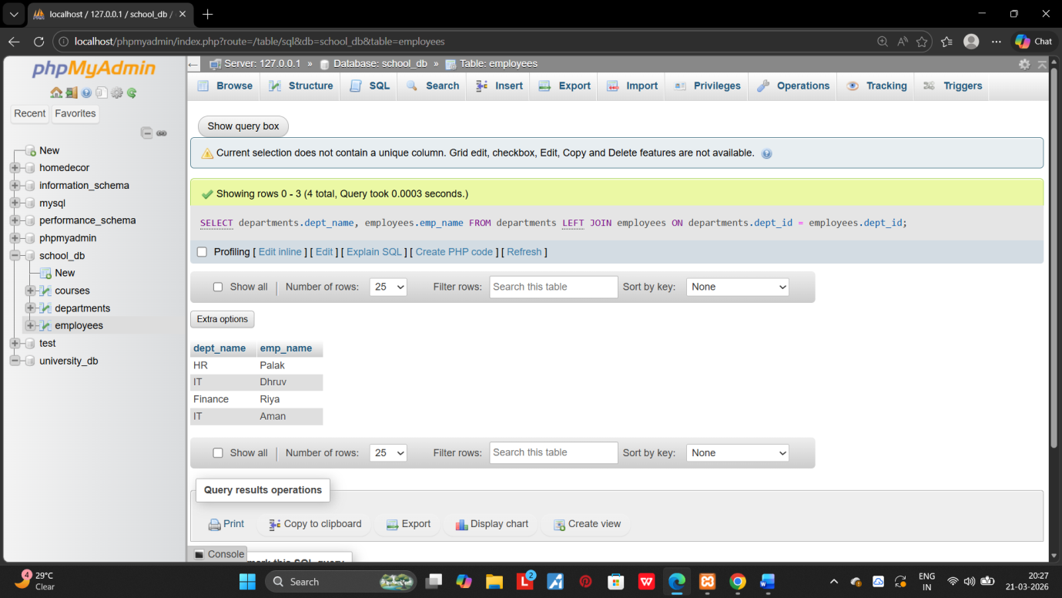

12.SQL GROUP BY:

1.grorp employees by department and count the number of employees in each department using GROUP BY.
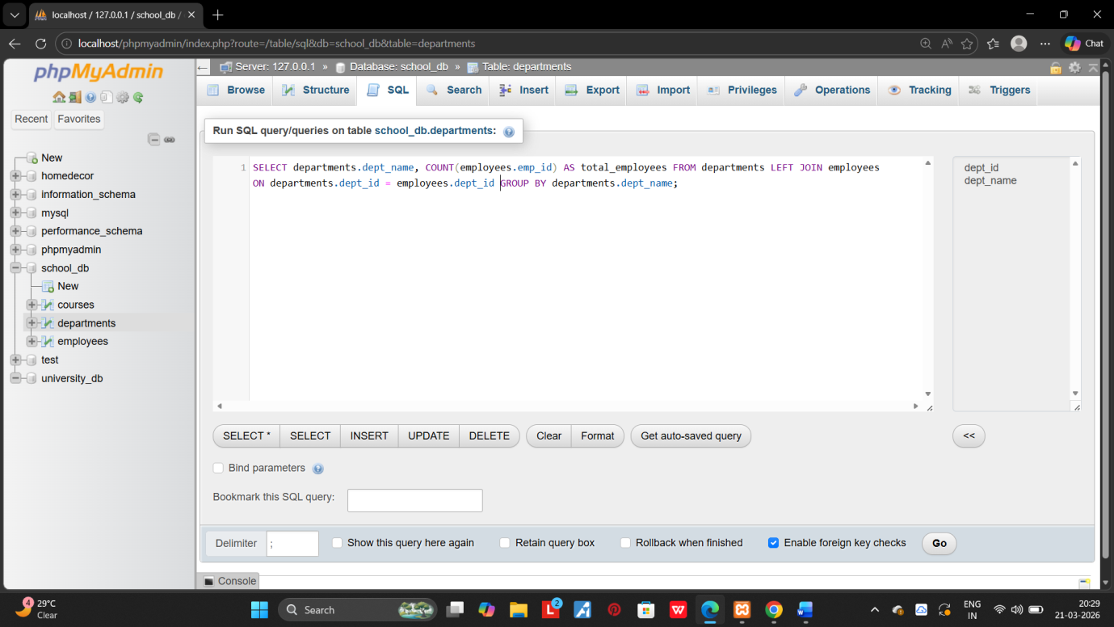
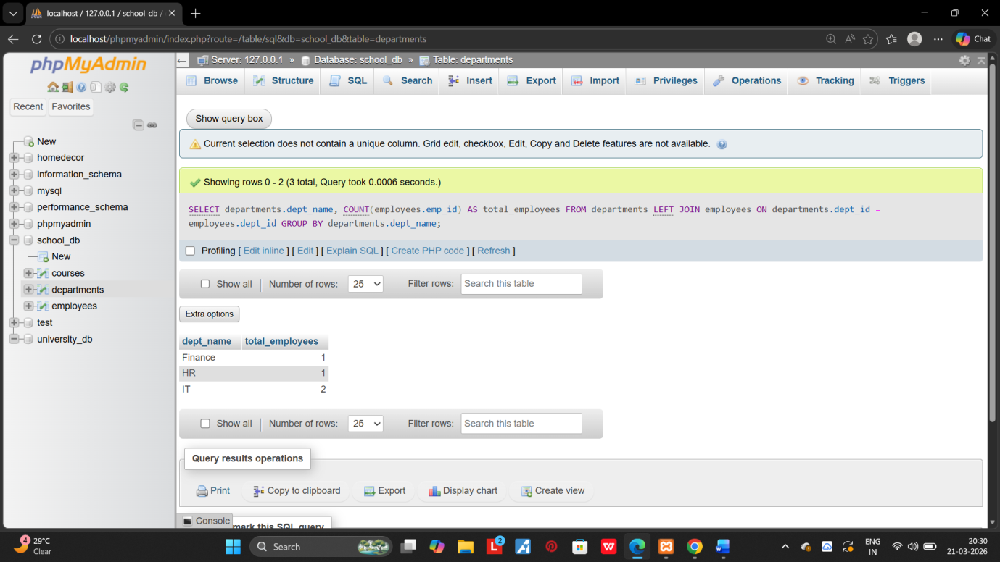
2.Use the AVG aggregate function to find the average salary of employees in each department. 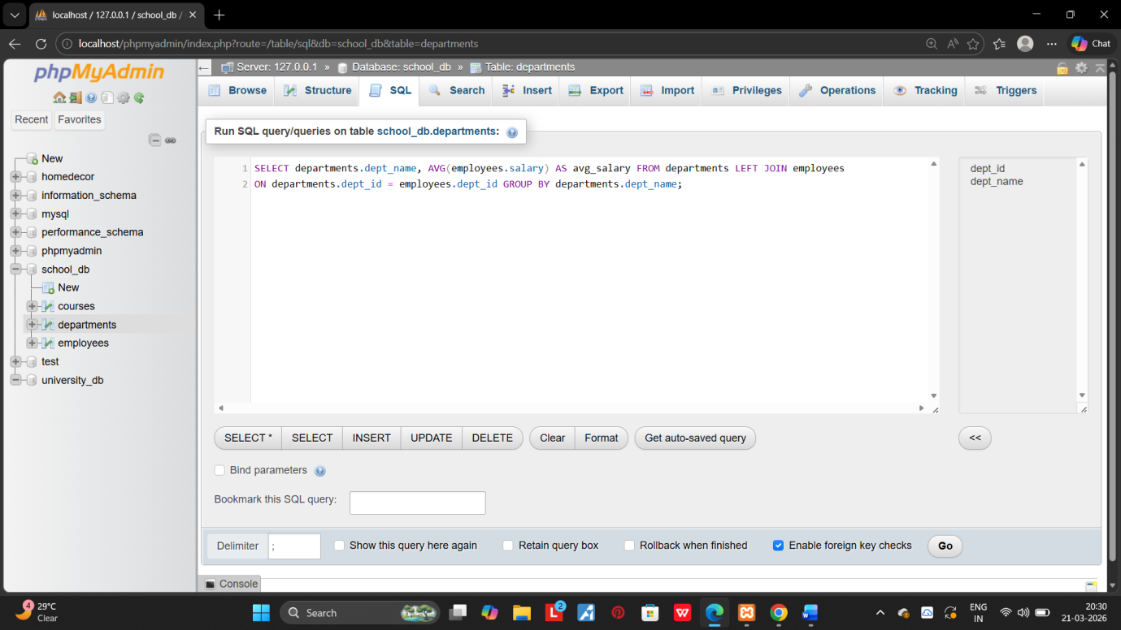
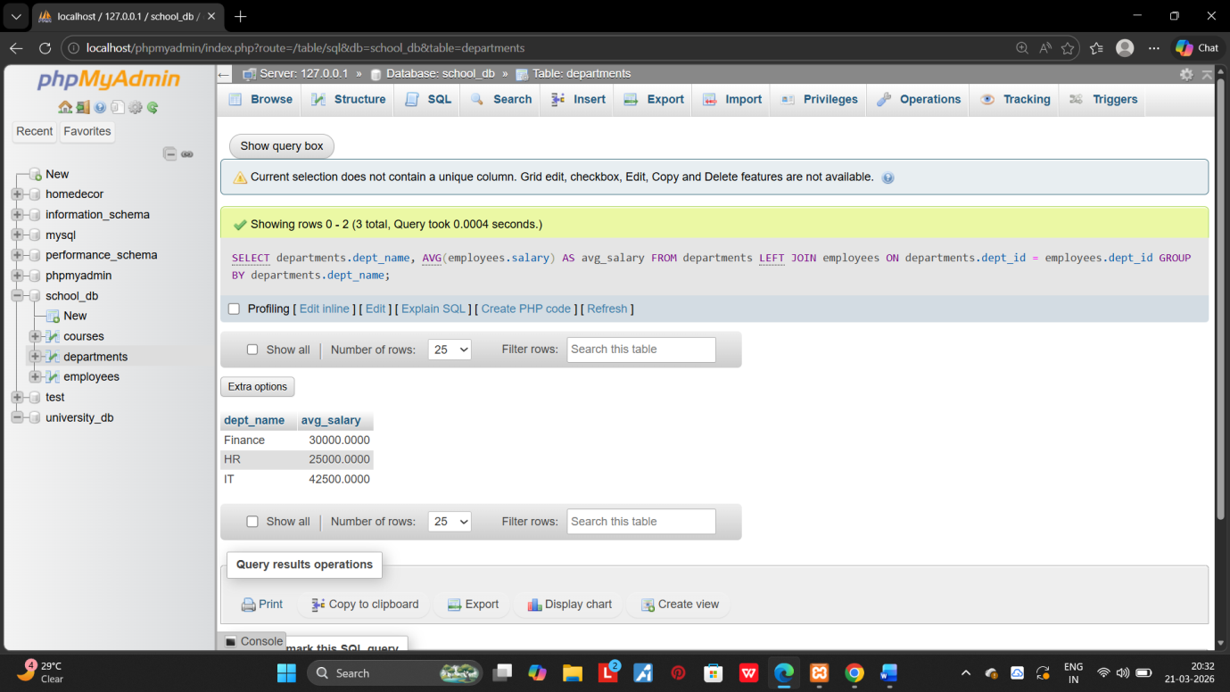

13.SQL STORED PROCEDURE:

1.Write a stored procedure to retrive all employess from the employess table based on department. 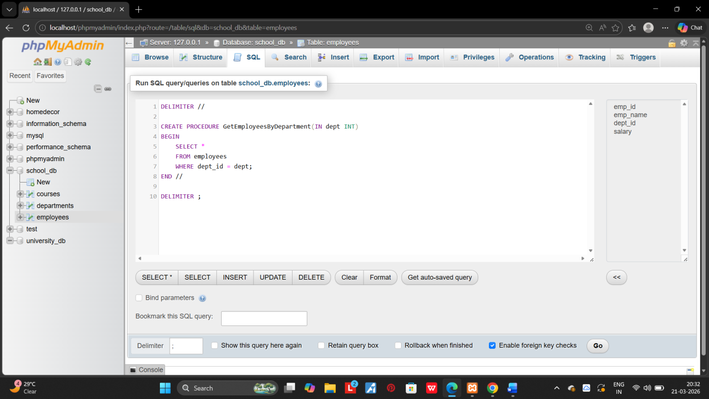
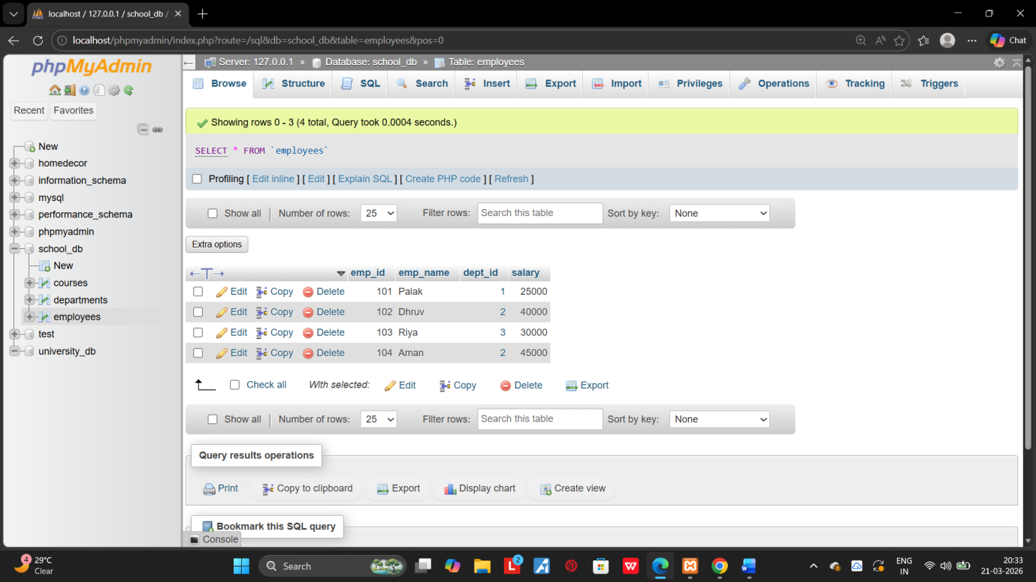
2.Write a stored procedure that accepts course_id as input and returns the course details. 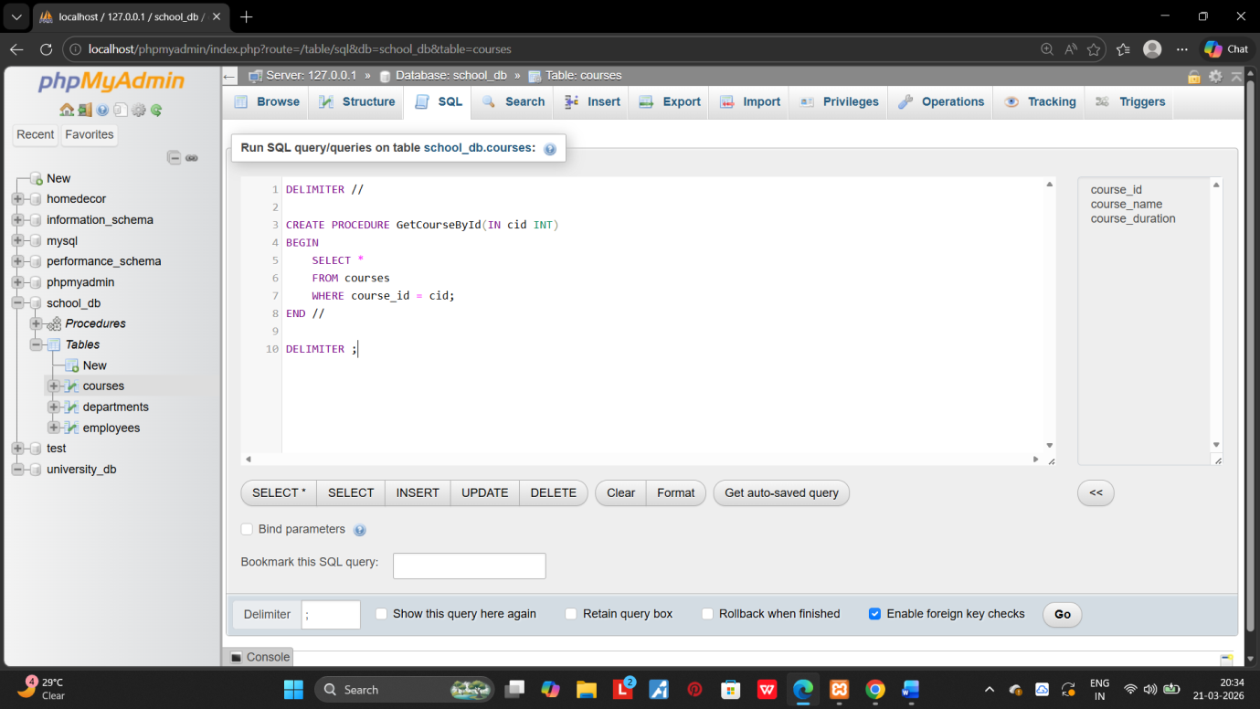
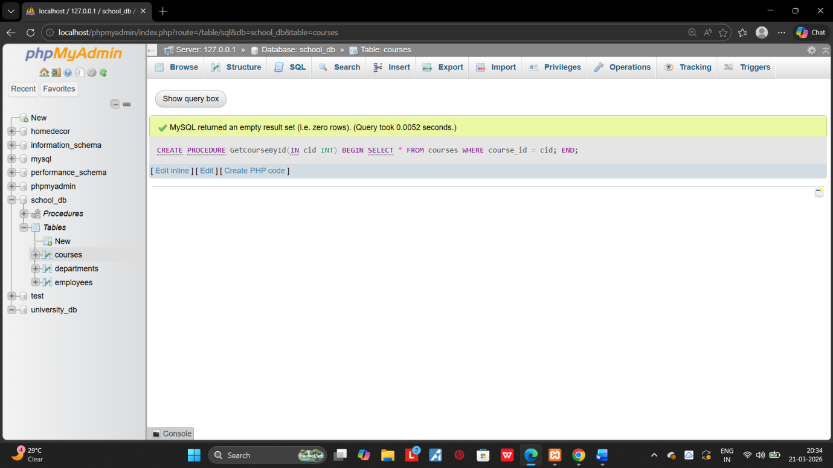

14.SQL VIEWL:

1.Create a view to show all employees along with their department names. 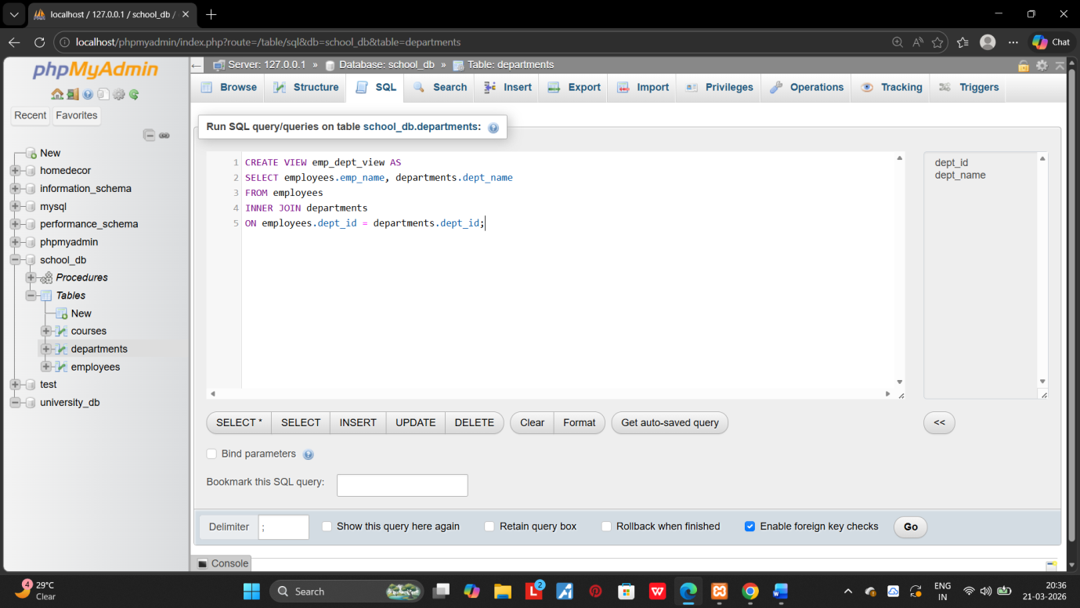
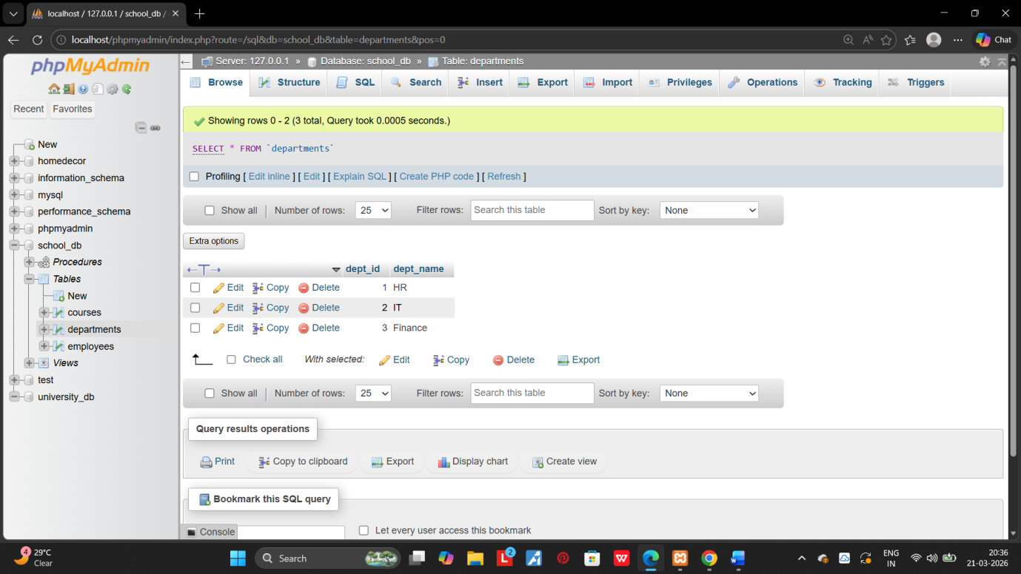

2.Modify the view to exclude employees whose salaries are below $50,000.
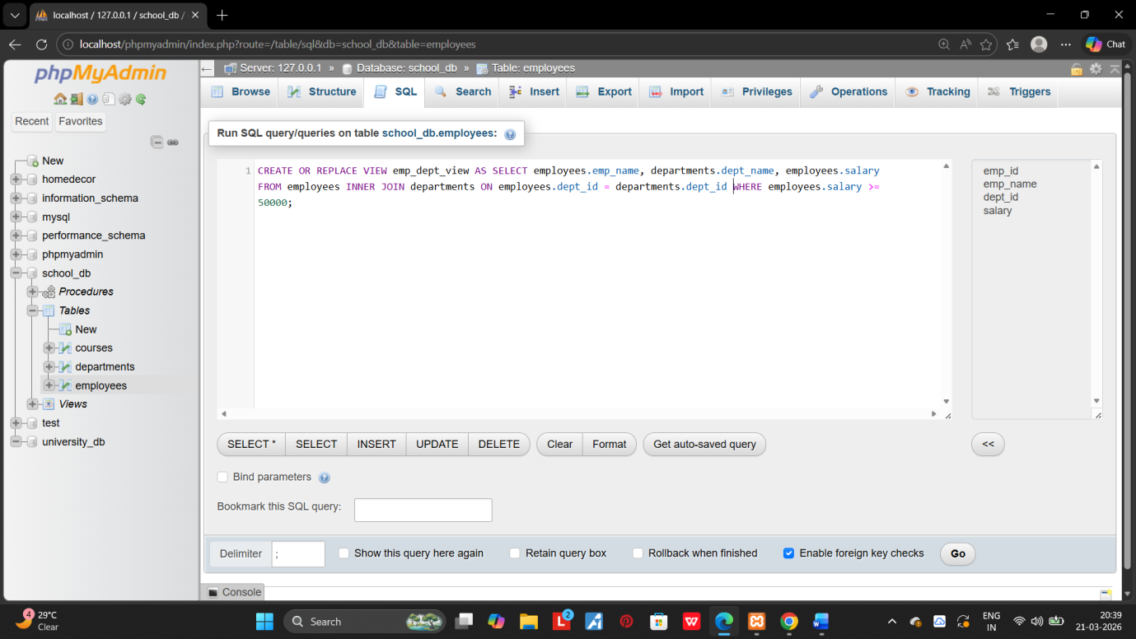
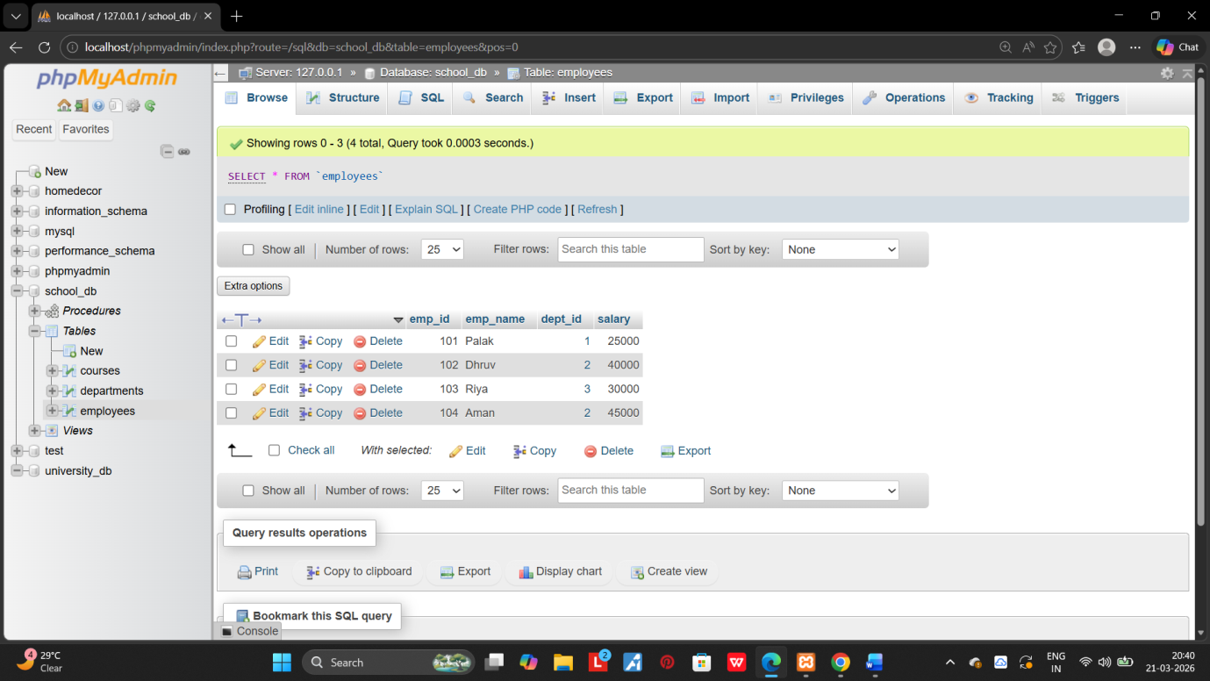

15.SQL TRIGGERS:
1.Create a tigger to automatically log changes to the employees table when a new employee is added. 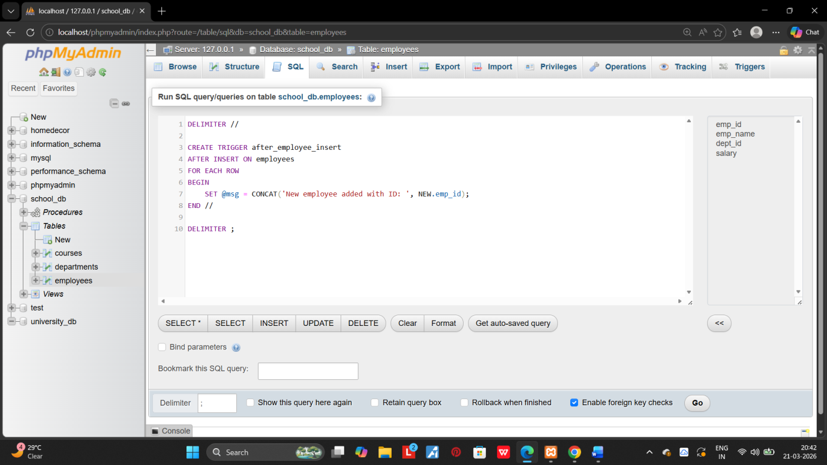
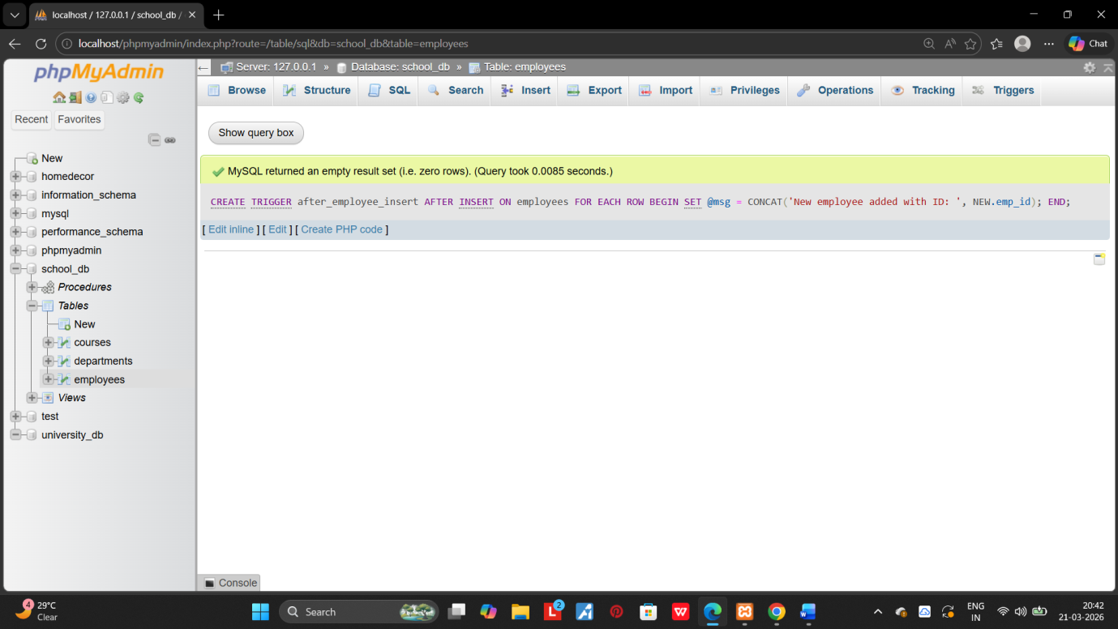
2.Create a tigger to update the last_modified timestamp whenever an employee record is updated. 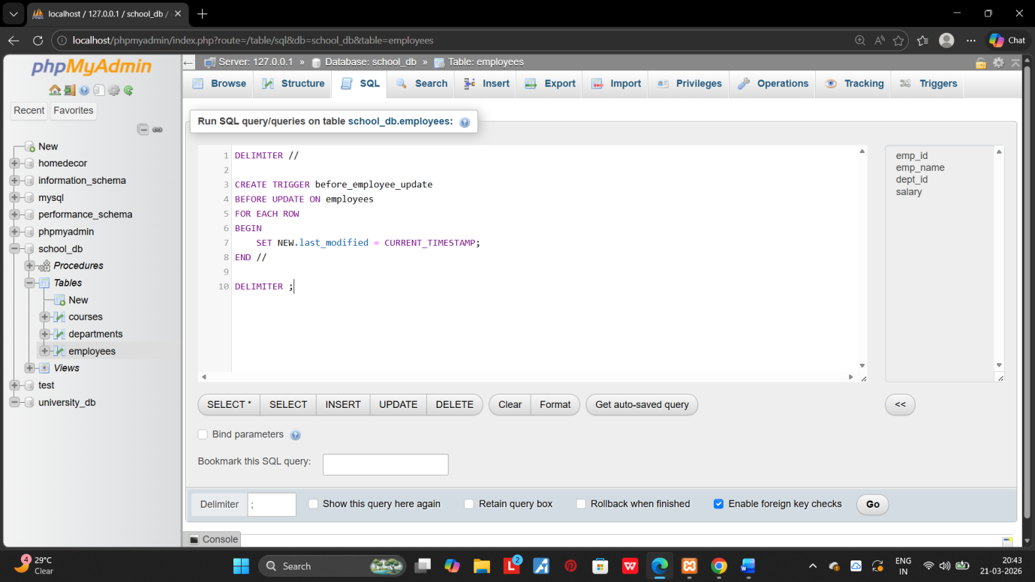
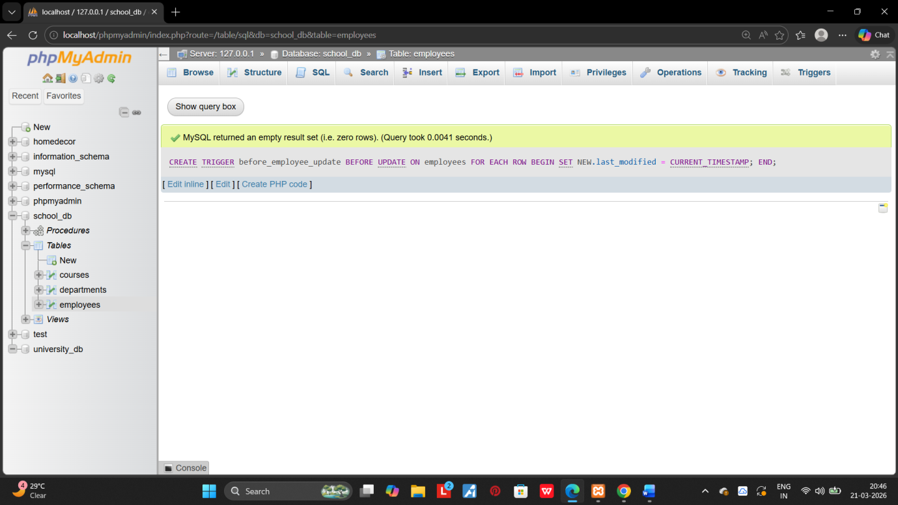

16.INTRODUCTION TO PL/SQL:

1.Write a PL/SQL block to print the total number of employees from the employees table. 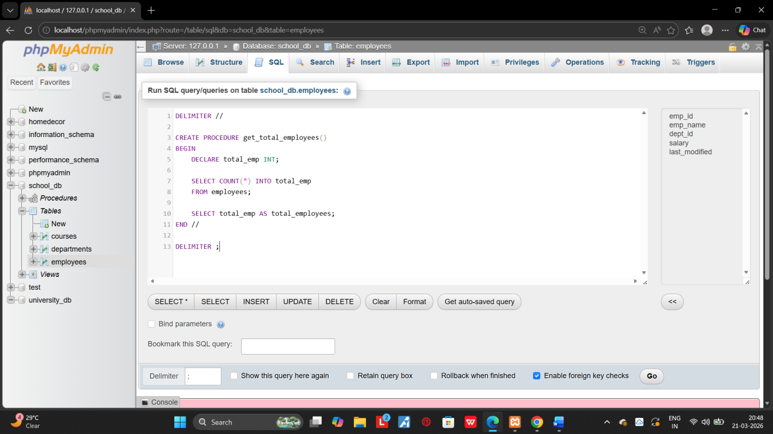
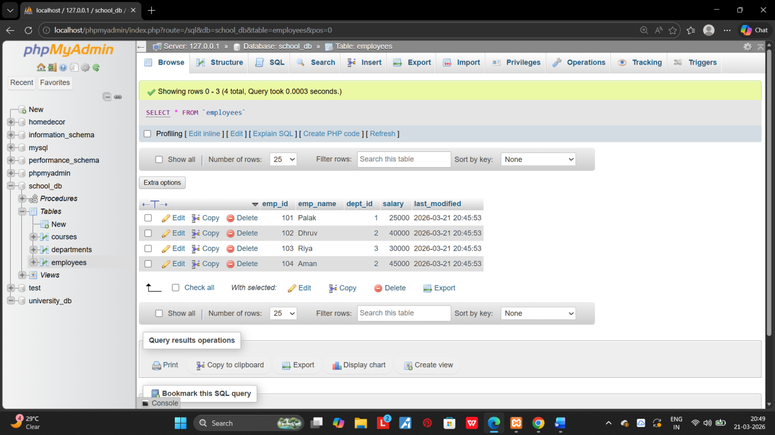
2.Create a PL/SQL block that calculates the total sales from an ordees tables. 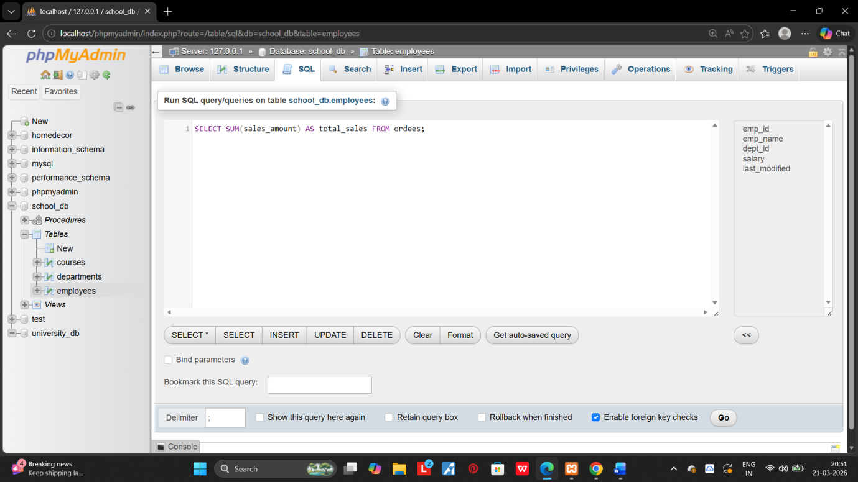

17.PL/SQL CONTROL STRUCTURES:

1.Write a PL/SQL block using an IF-THEN condition to check the department of an employee. 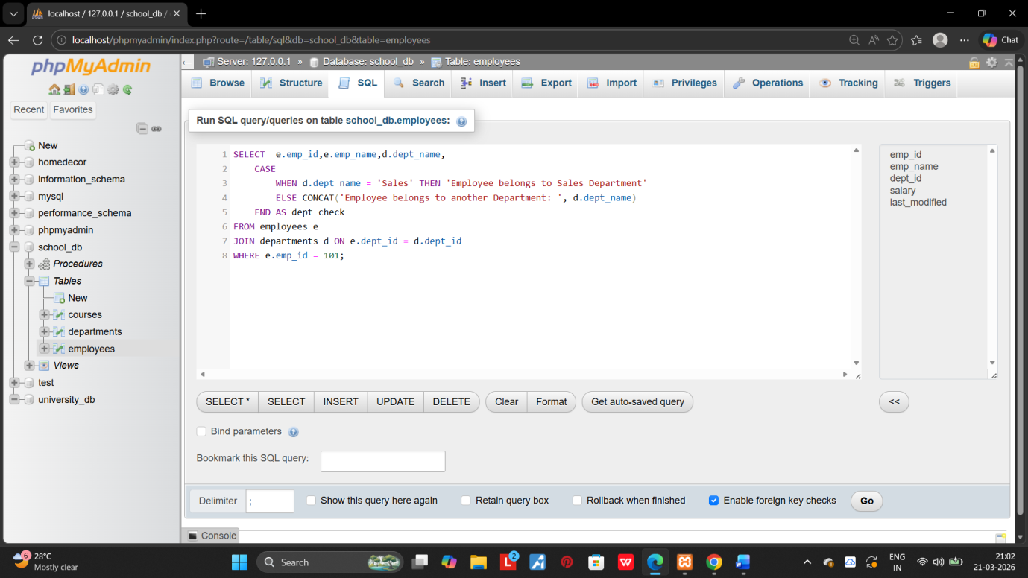 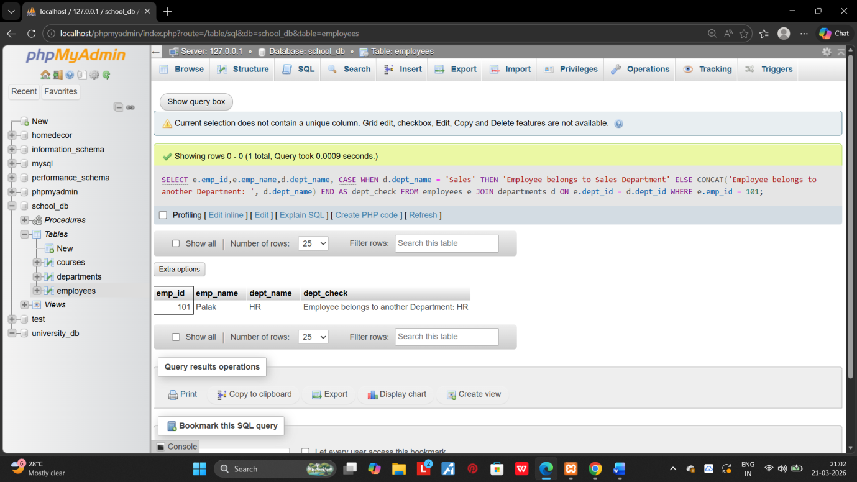

2.use a FOR LOOP to iterate through employee records and display their names.
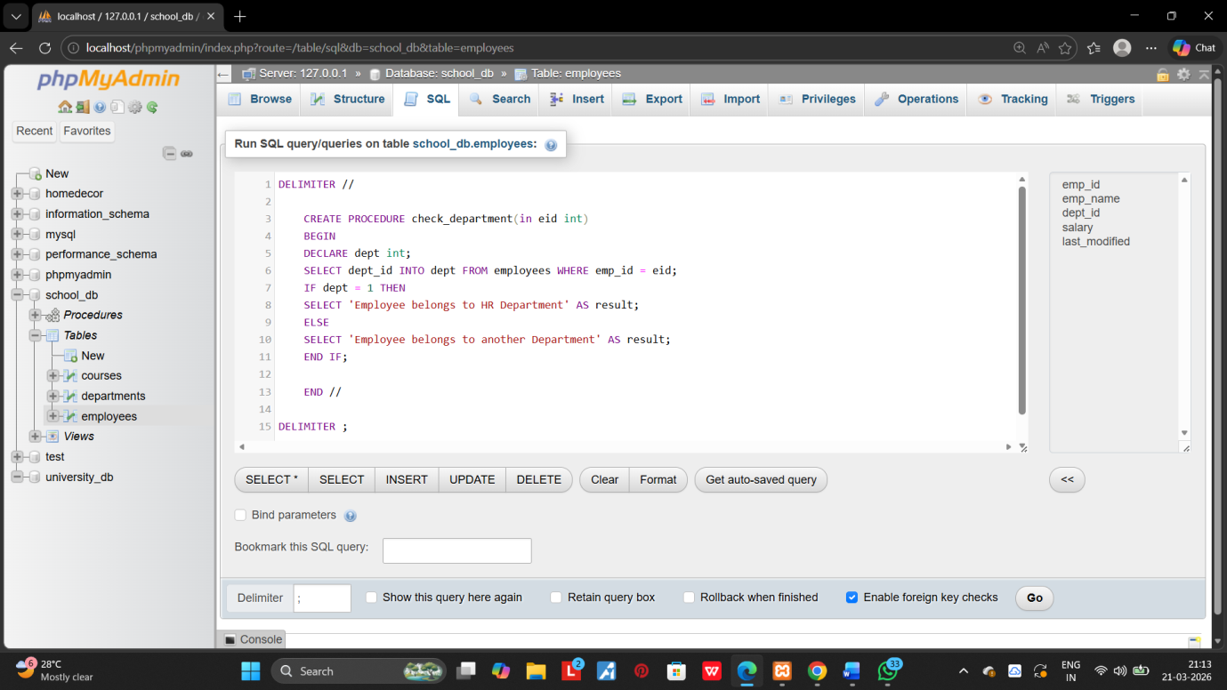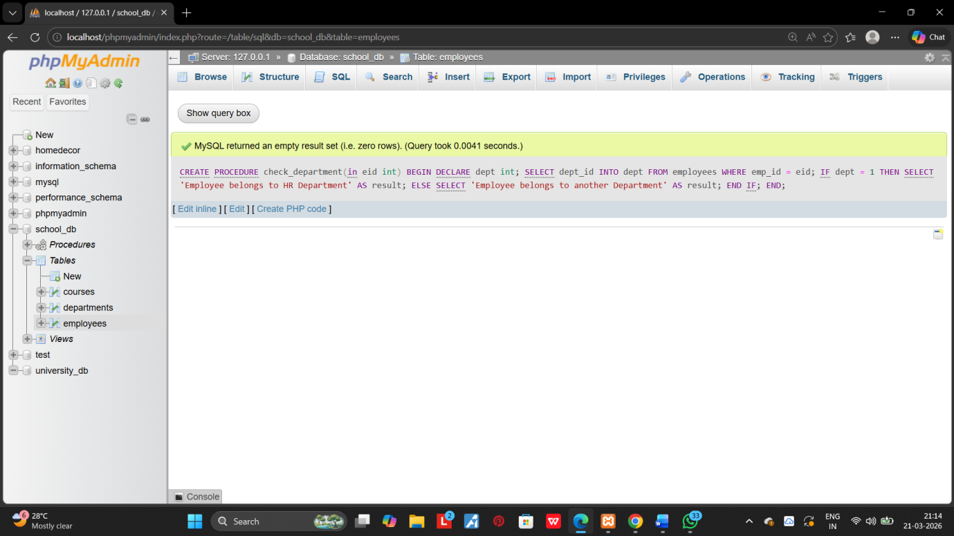

18.SQL CURSORS:

1.Write a PL/SQL block using an explicit cursor to retrieve and display employee details.
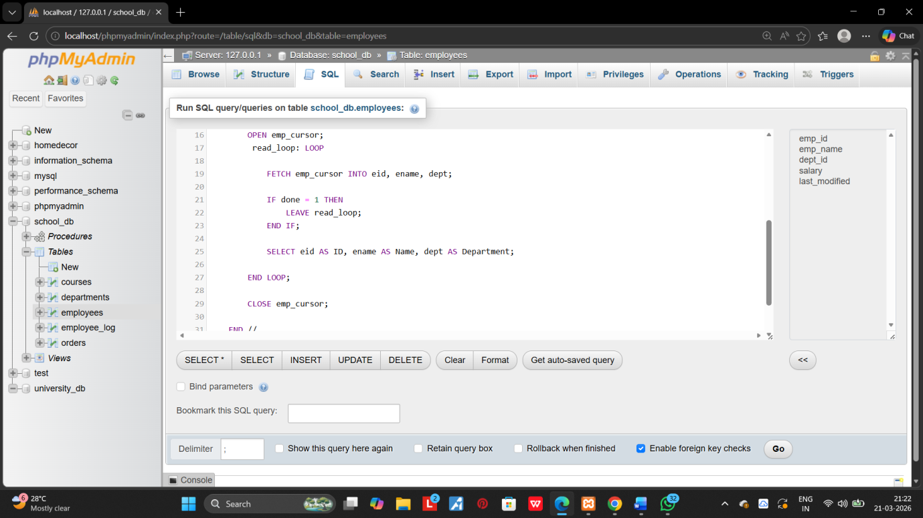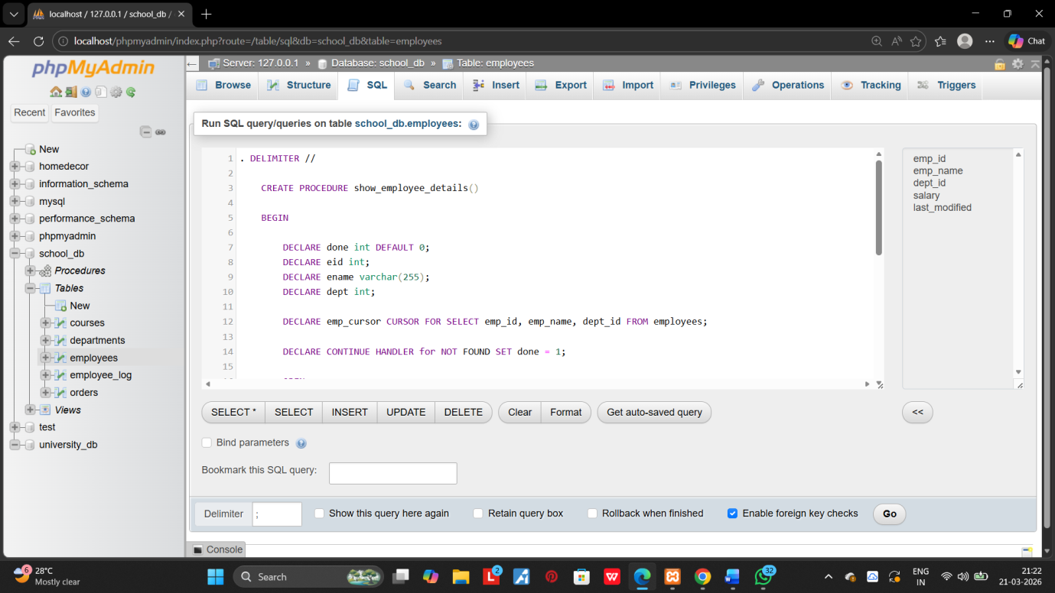
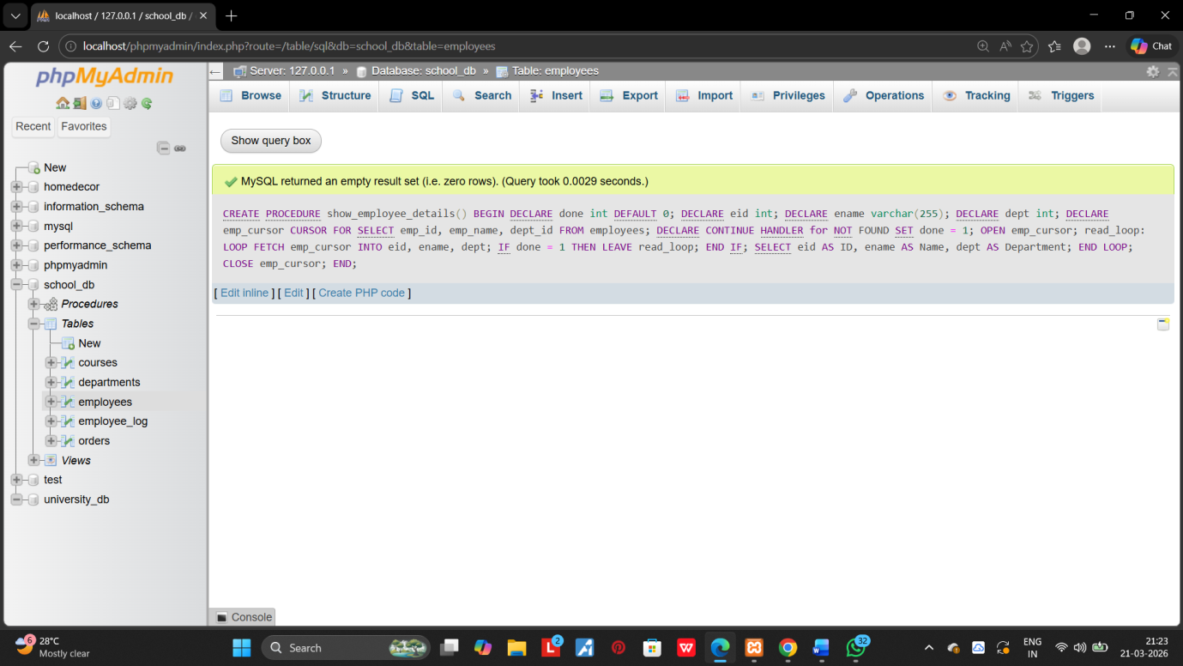

2.Create a cursor to retrieve all course and display them one by one.
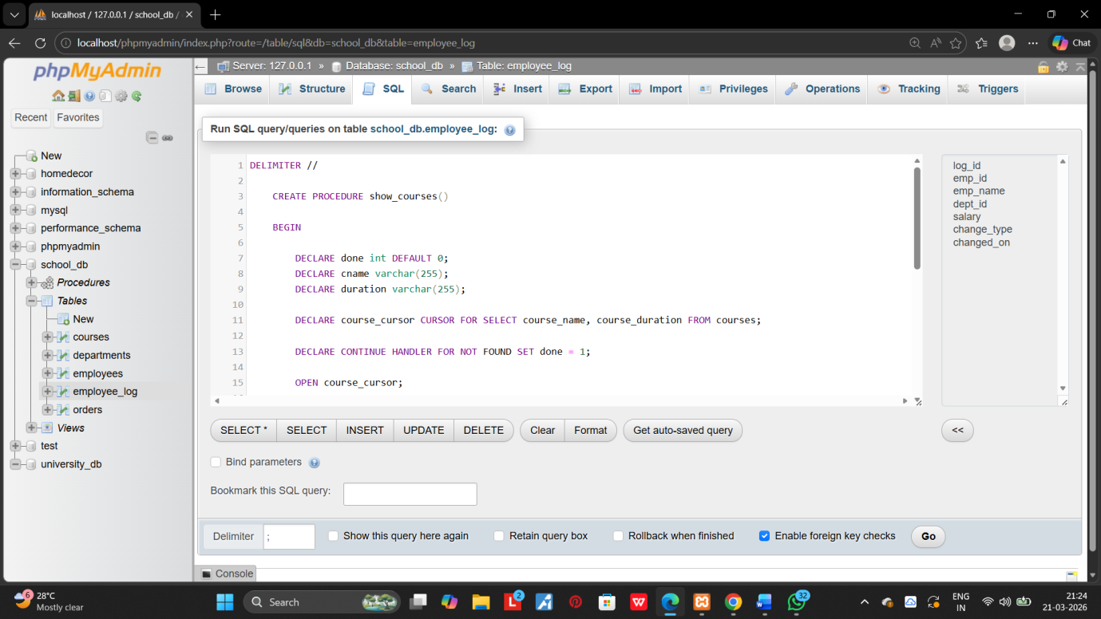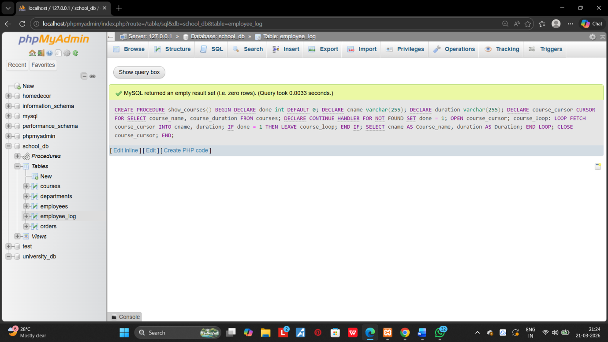

19.ROLLBACK AND COMMIT Savepoint:

1.Perform a transaction where you create a savepoint , insert records, then rollback to the savepoint. 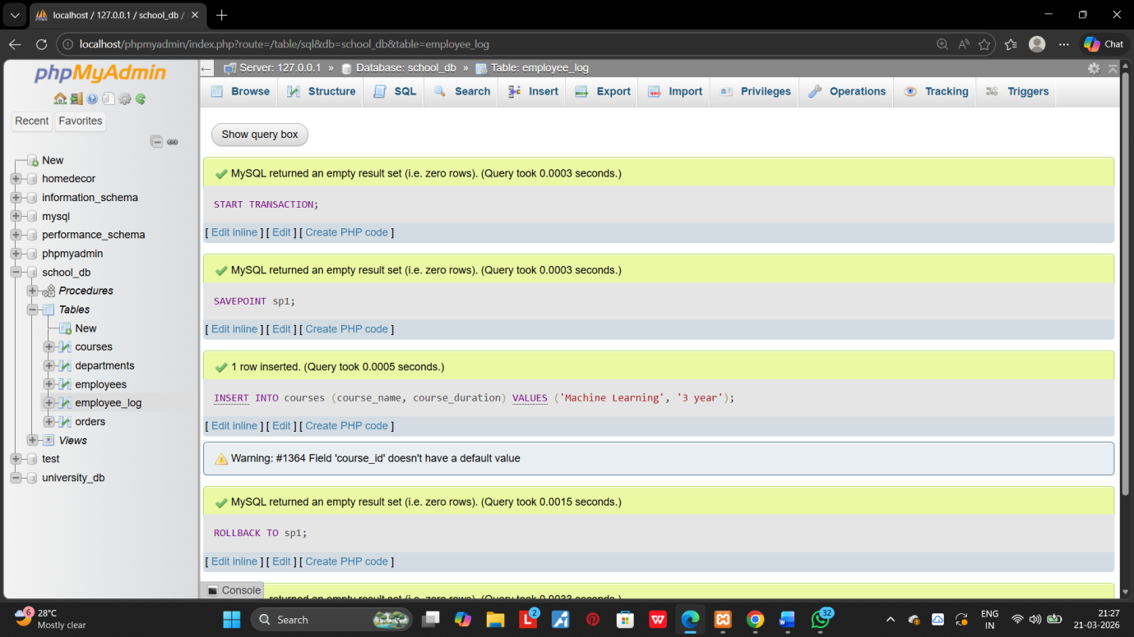
2.commit part of transition after using a savepoint and then rollback the remaining chages. 